ABOUT US
The word LIPSA means Love and Desire—a feeling that deeply connects every woman with her unique sense of beauty.
Founded in 2018 by Poulami Das, Sayani Dutta, and Sanjana Saha, LIPSA was born from a simple yet powerful realization: a woman’s love for beauty isn't about altering her identity, but about celebrating her inner grace and confidence. That passion for self-expression became the heartbeat of our brand.
At LIPSA, we create high-performance, skin-conscious beauty essentials crafted to honor your everyday romance with cosmetics. Every shade, texture, and blend is designed to match your passion, giving you the power to express every side of who you are.
Because true beauty begins with love—and LIPSA is our love letter to you.
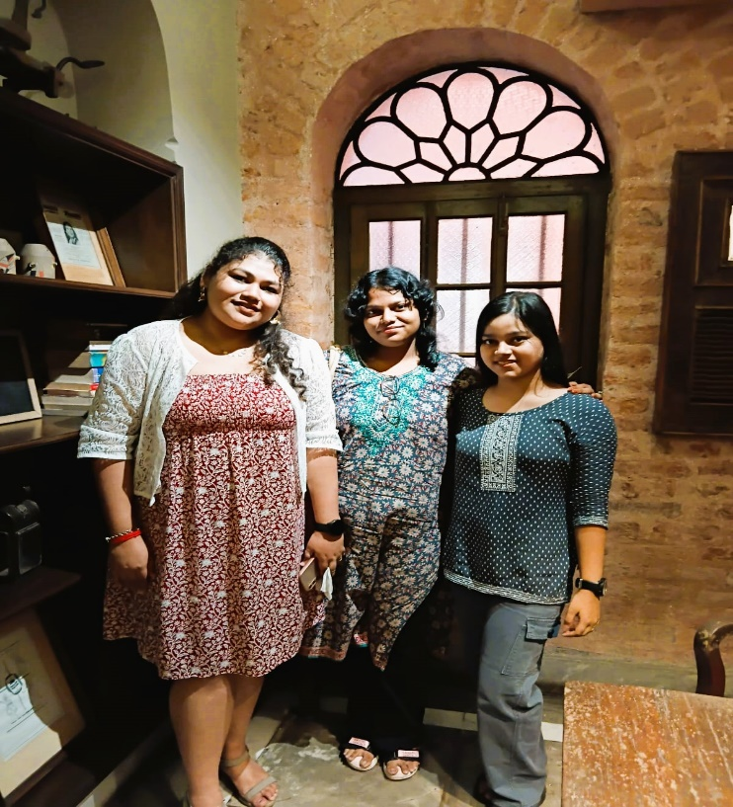
Follow us on Instagram
https://www.instagram.com/im_poulami_206/?__pwa=1#
https://www.instagram.com/sanjanasaha21/?__pwa=1#
https://www.instagram.com/_.sd._.unofficial._/

